**Step1:Creating a new directory called flume_imp**

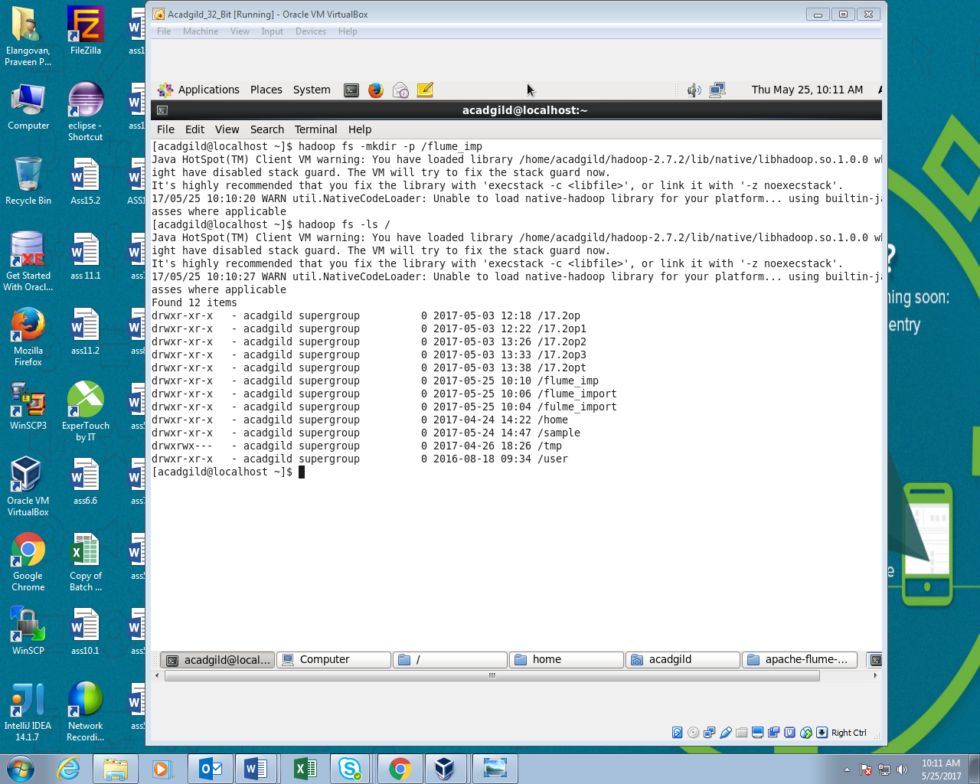

**Step2:Creating configure file in flume**

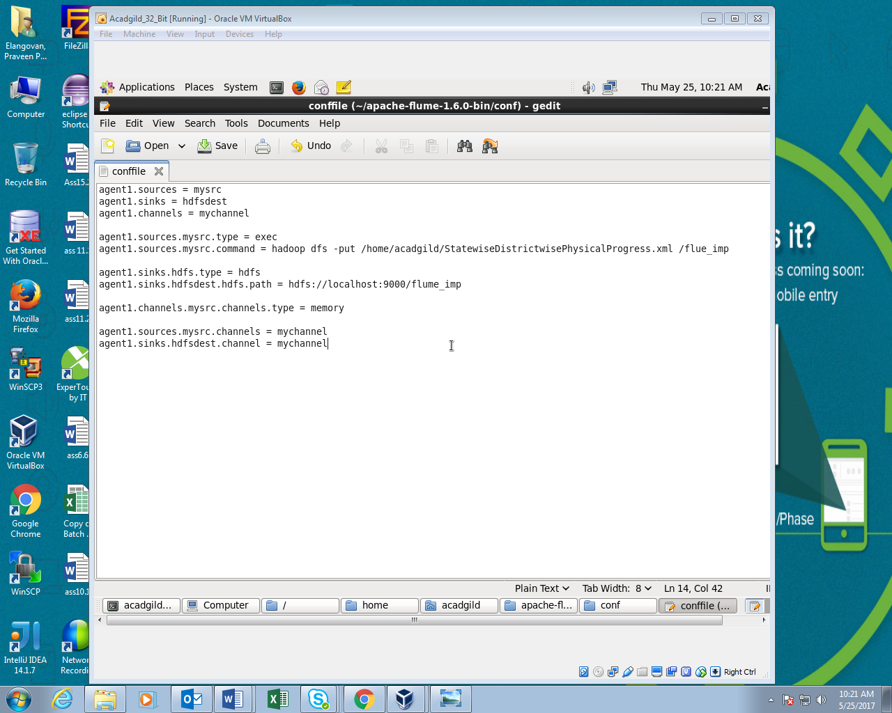

**Step3:Running configuration file**

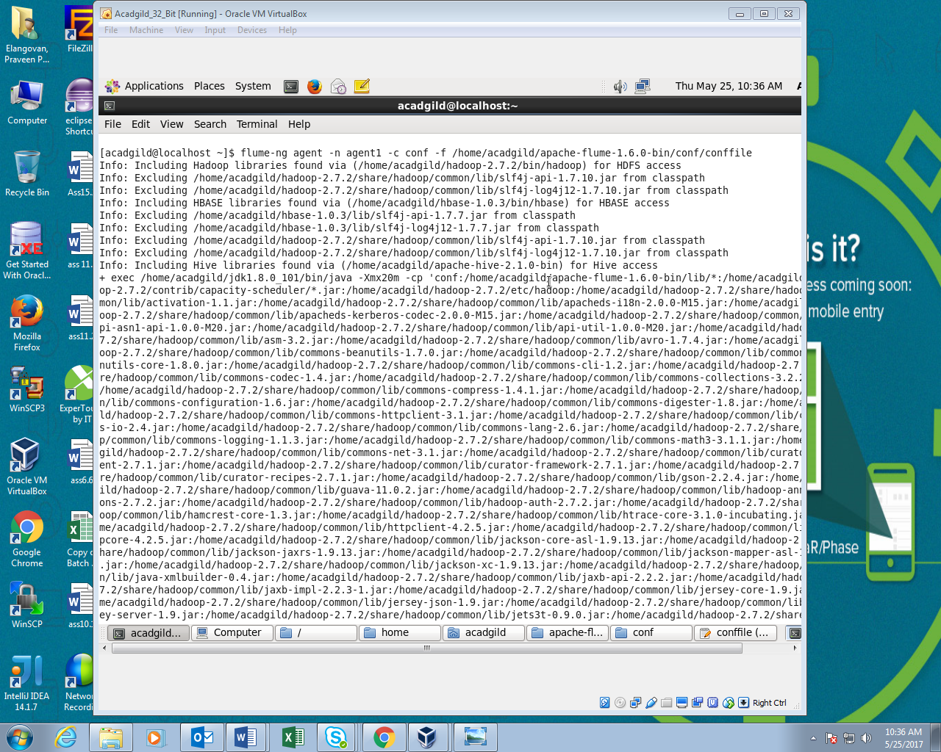

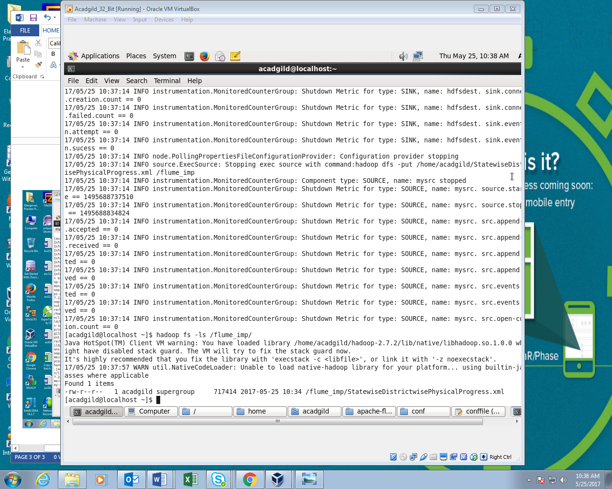

**Step4:Reading the file**

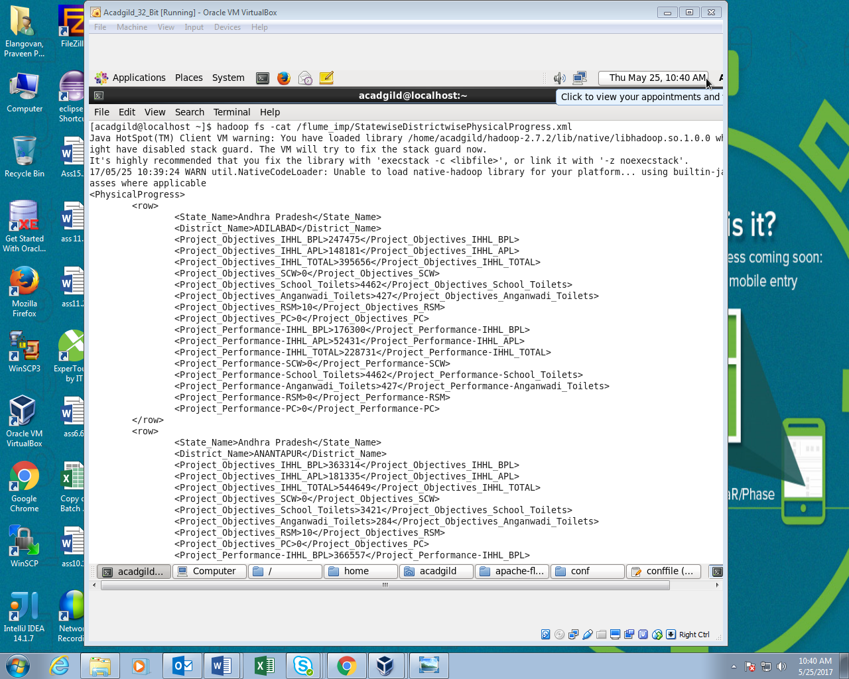

**Step5:Registring pig jar**

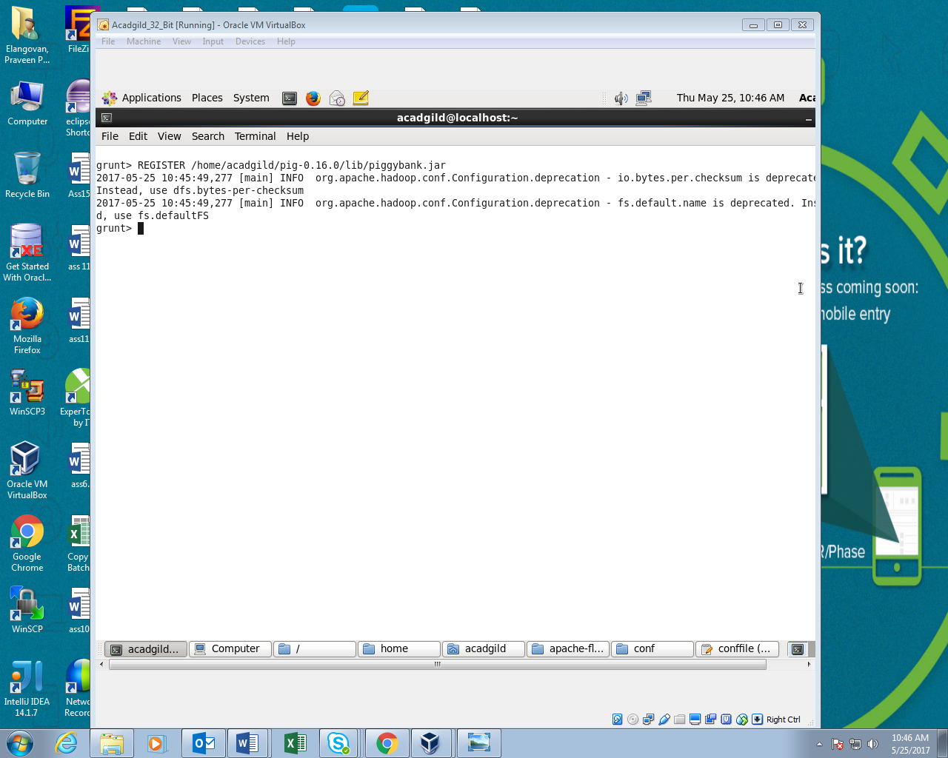

**Step6:Pig script**

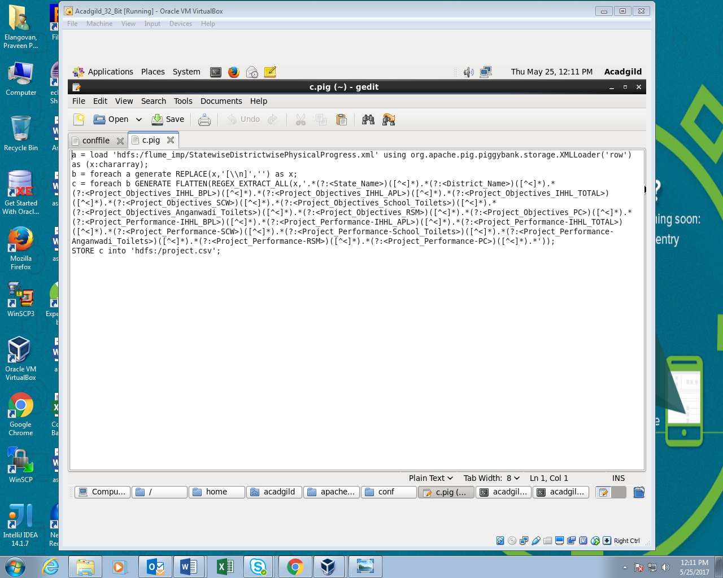

**Step7:Running Pig script**

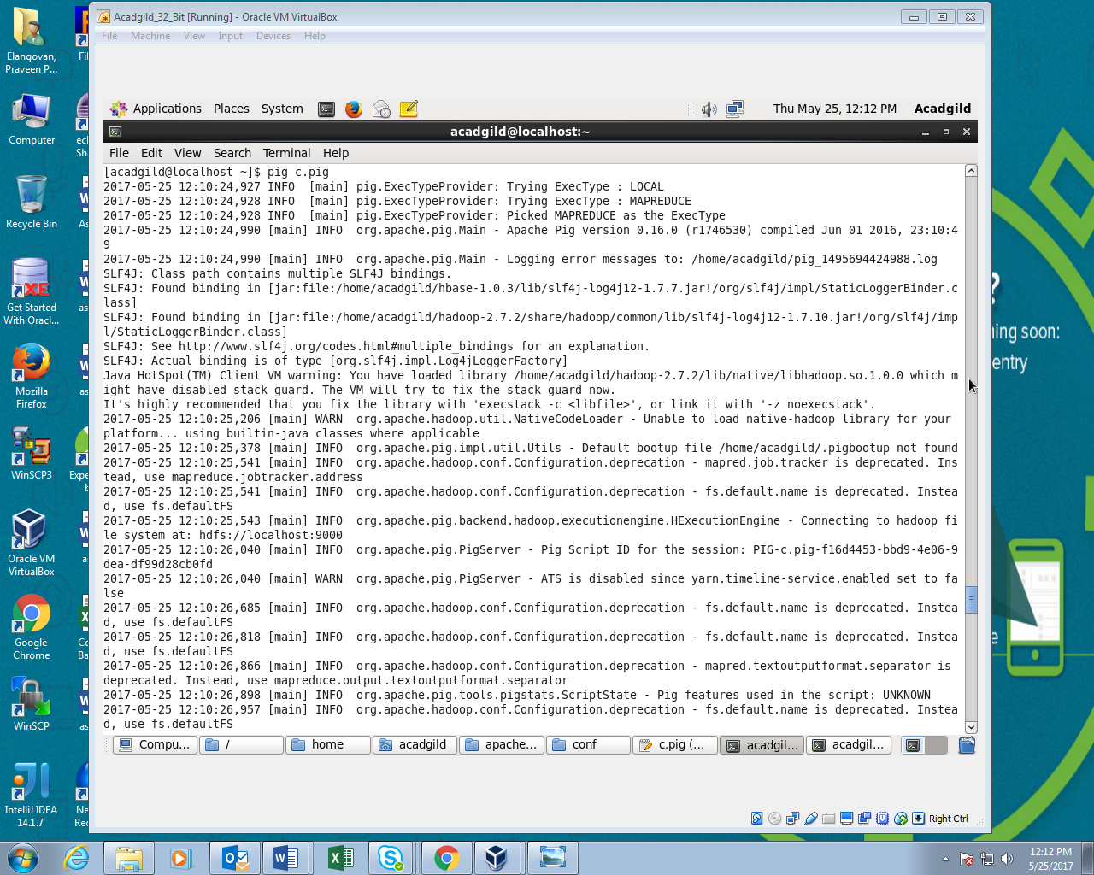

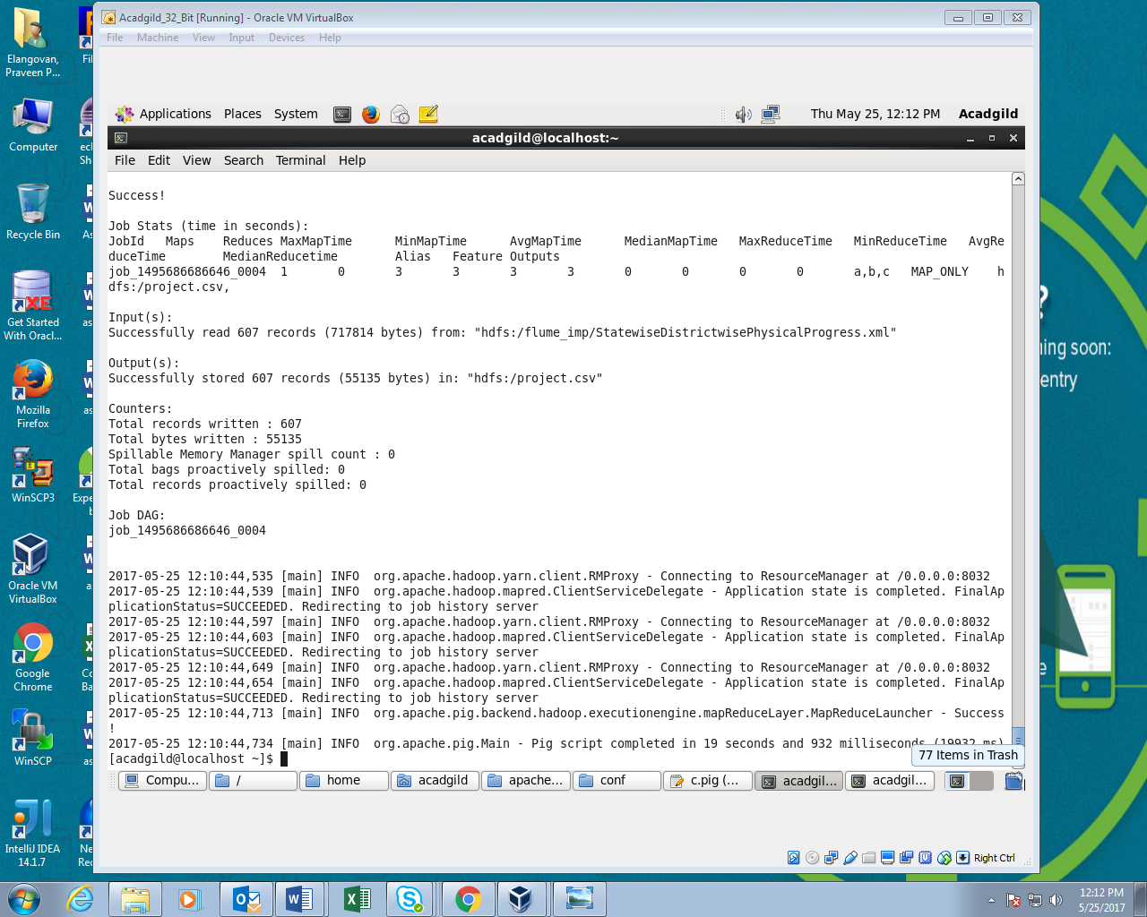

**Step8:Reading file using cat command**

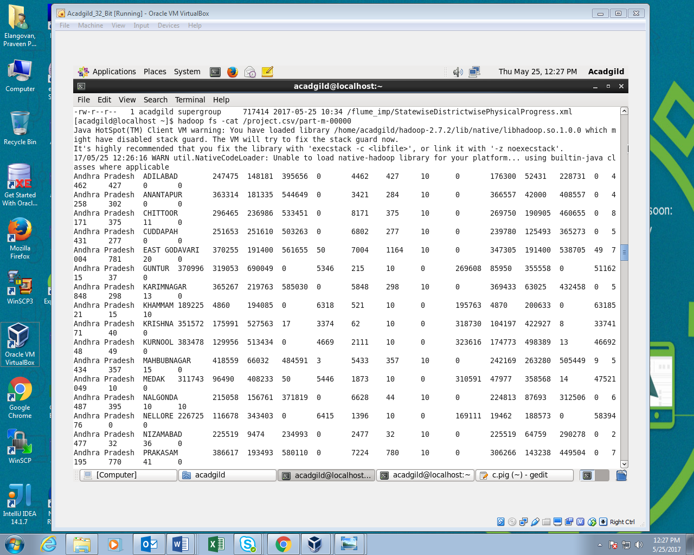

**QUESTION 1: Find out the districts who achieved 100 percent objective in BPL cards**

**Step1: Pig Script**

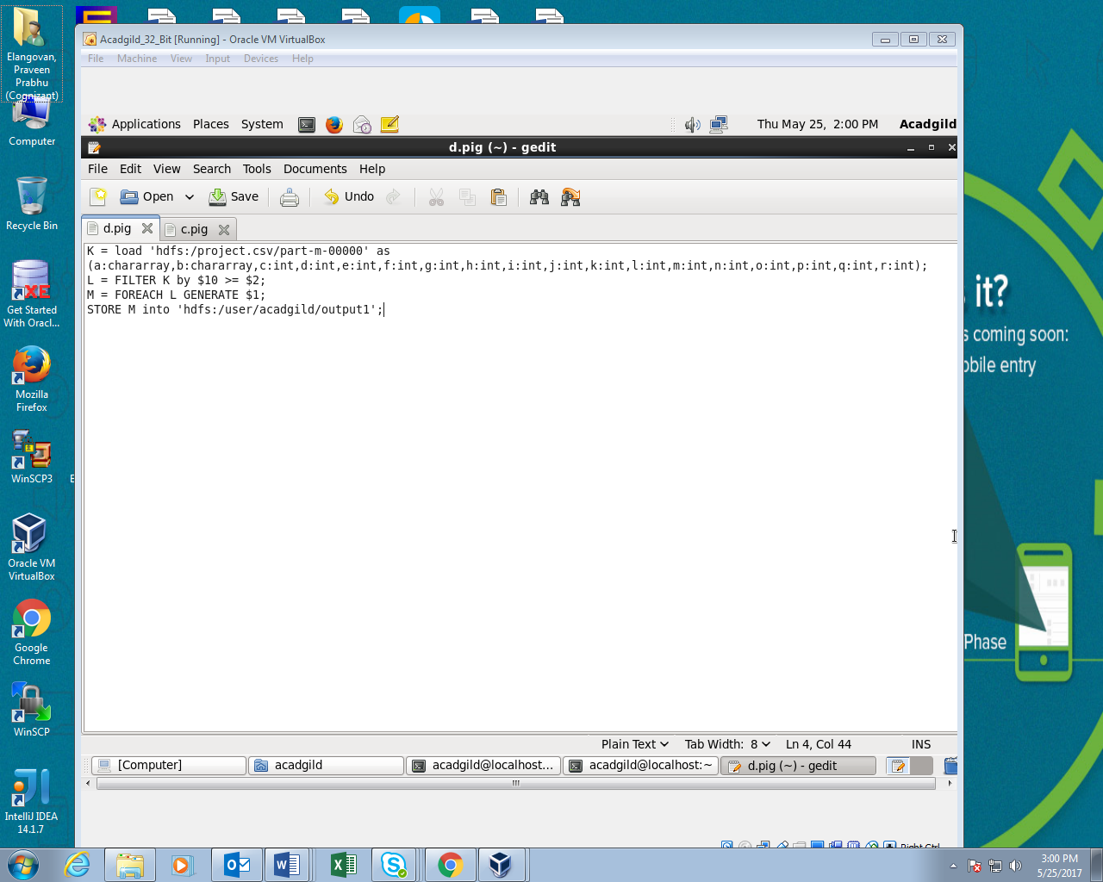

**Step2:Running Pig script**

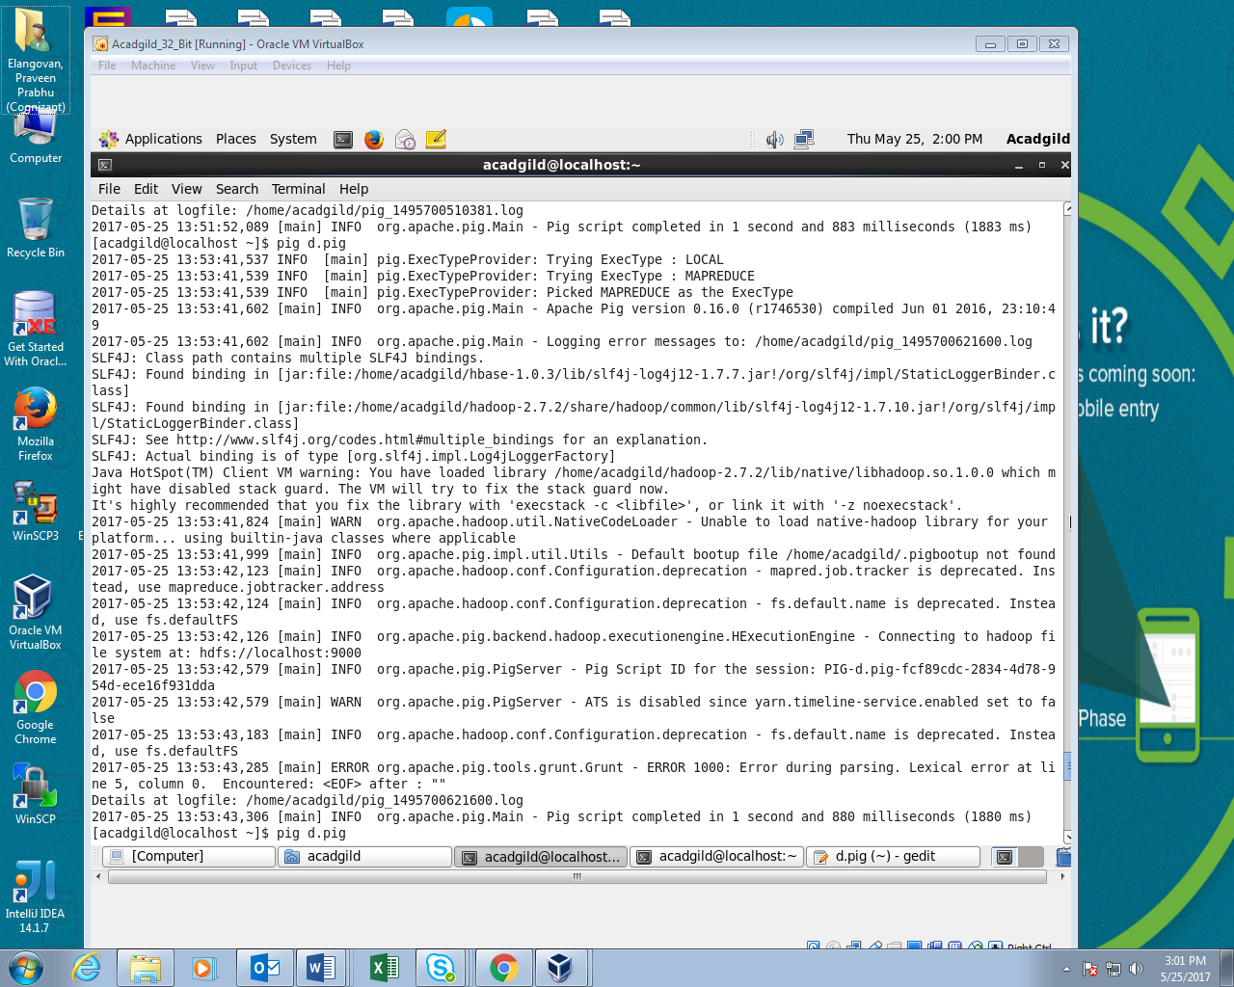

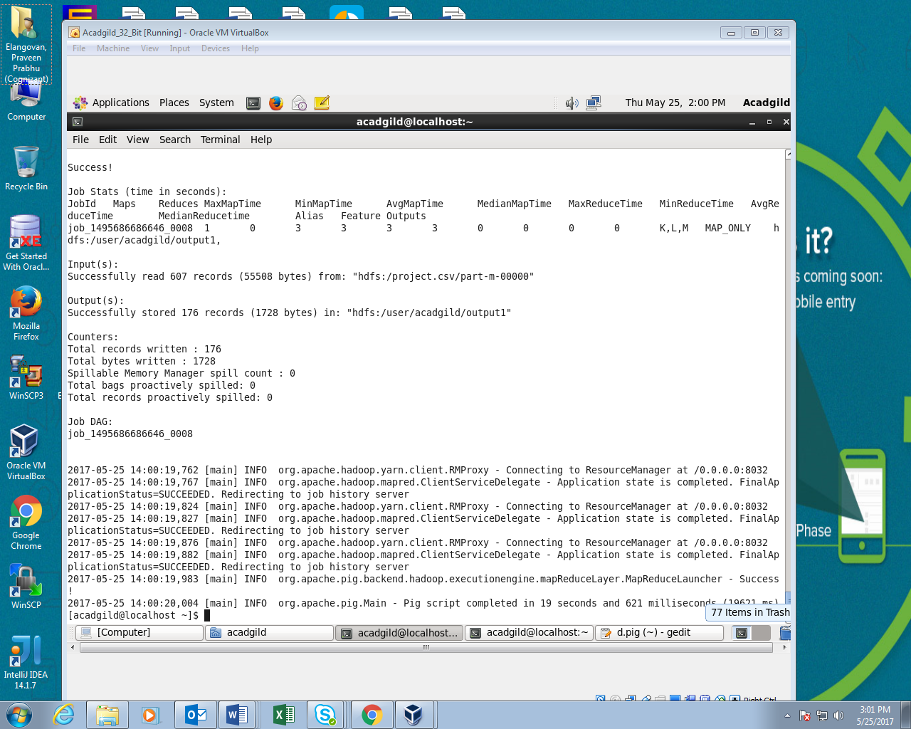

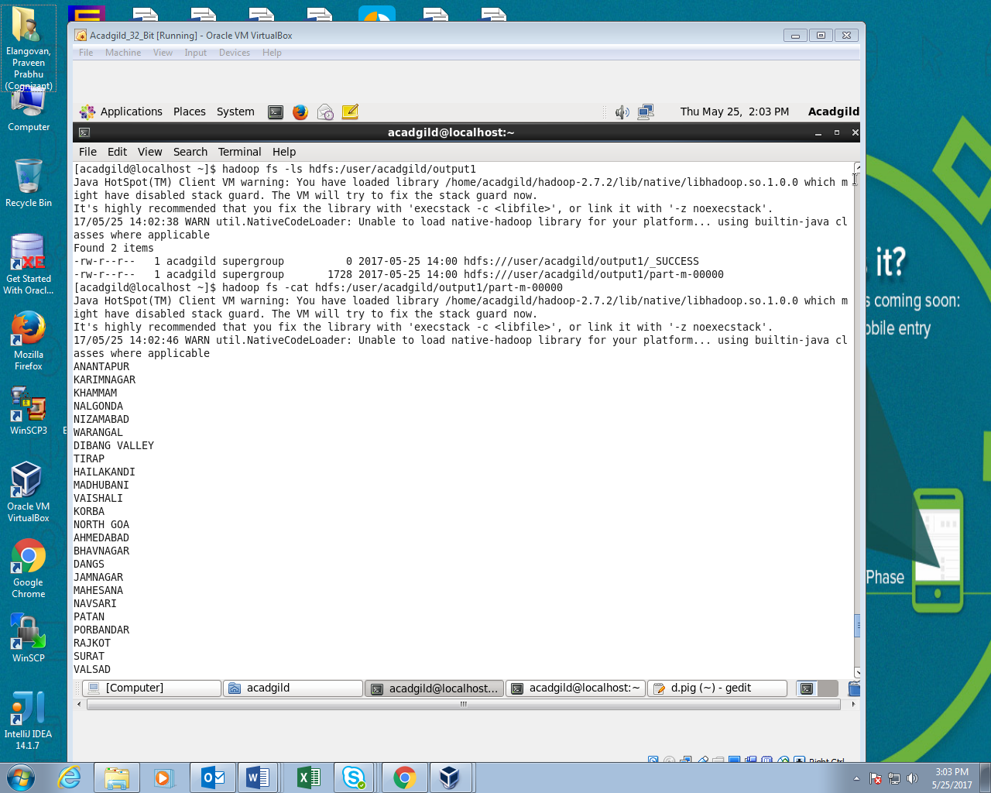

**Step3:Starting Sql and creating a new table named District**

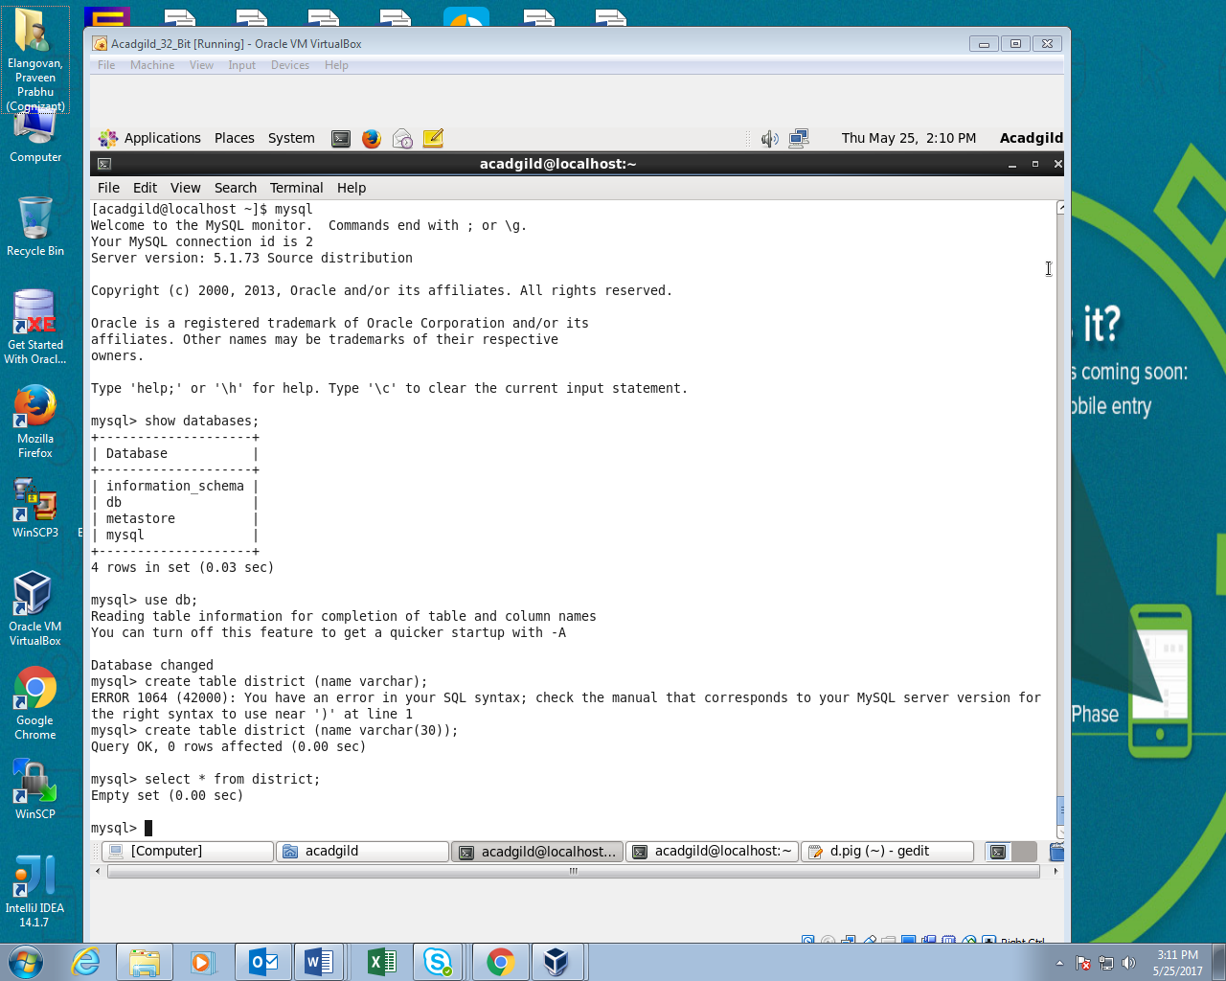

**Step4:Using Sqoop I’ve copied the data from pig to sql**

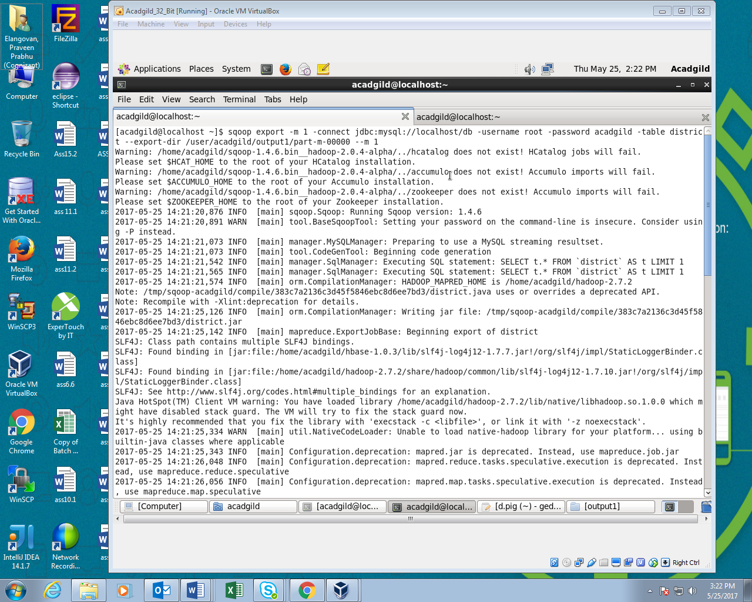

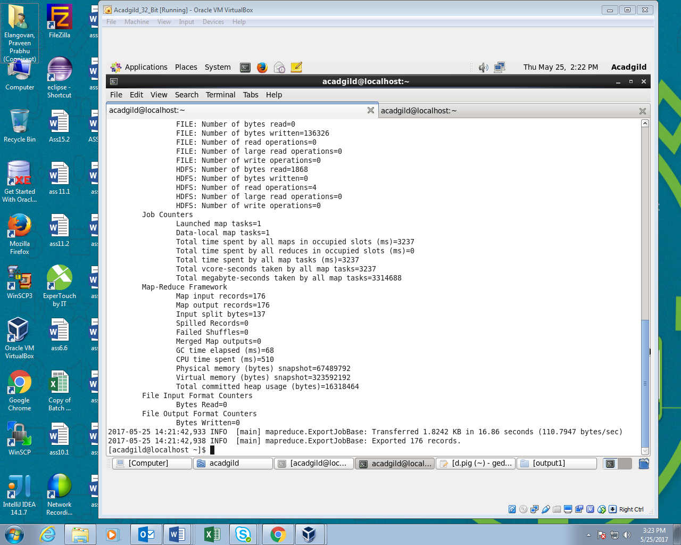

**Step5:Output**

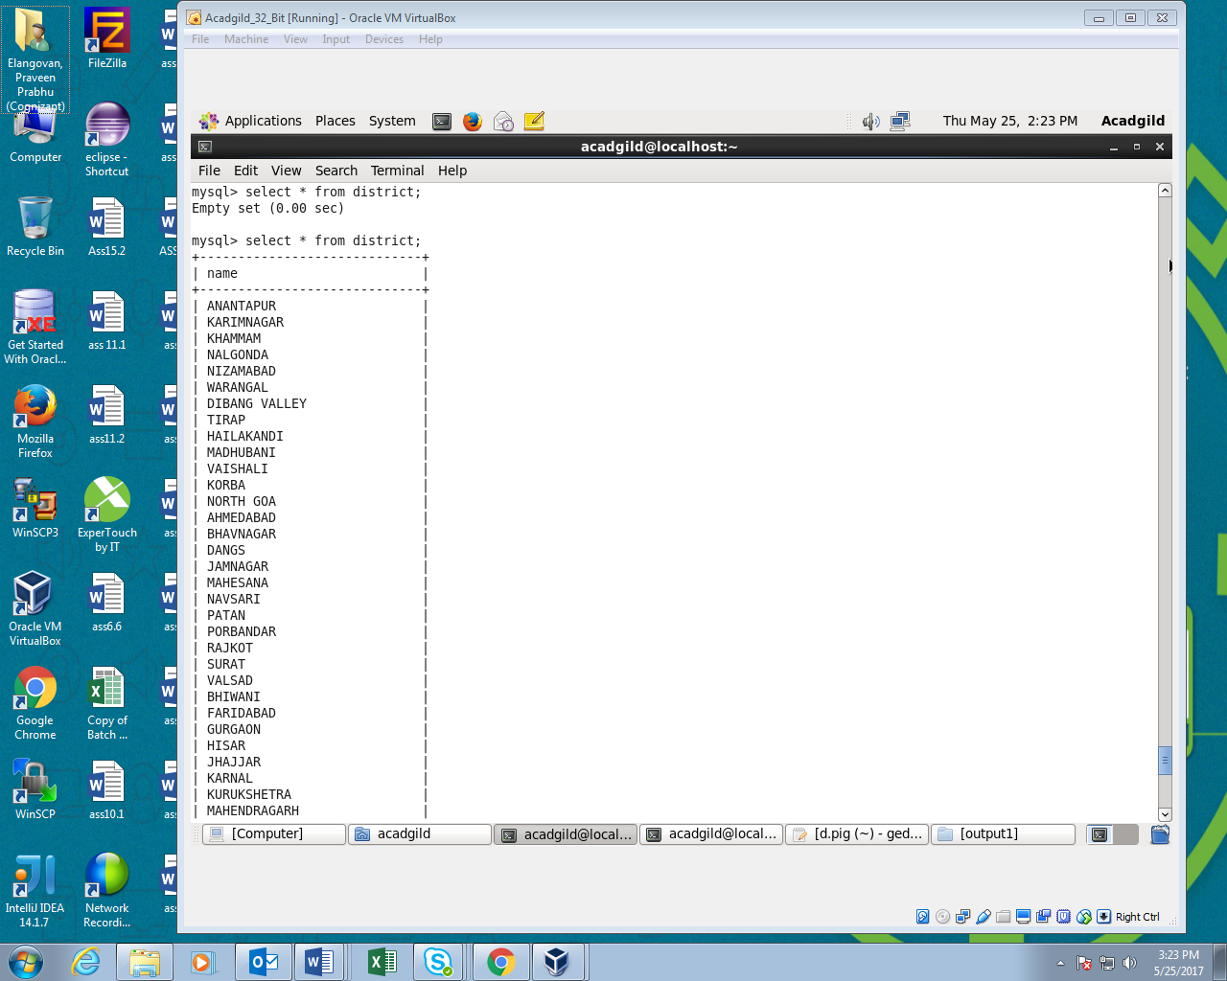

**Question2: Write a Pig UDF to filter the districts which have reached 80% of objectives of BPL cards.**

**Step1:jar file for pig udf**

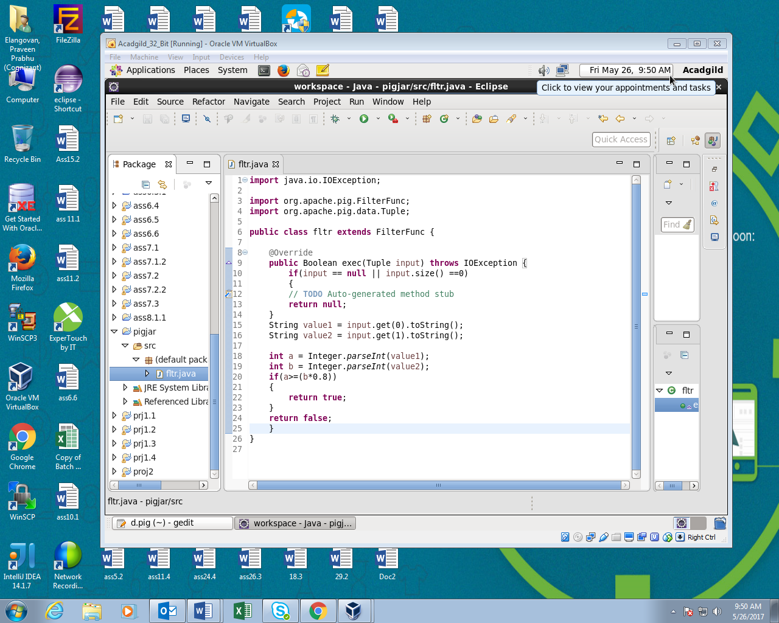

**Step2:Pig Script**

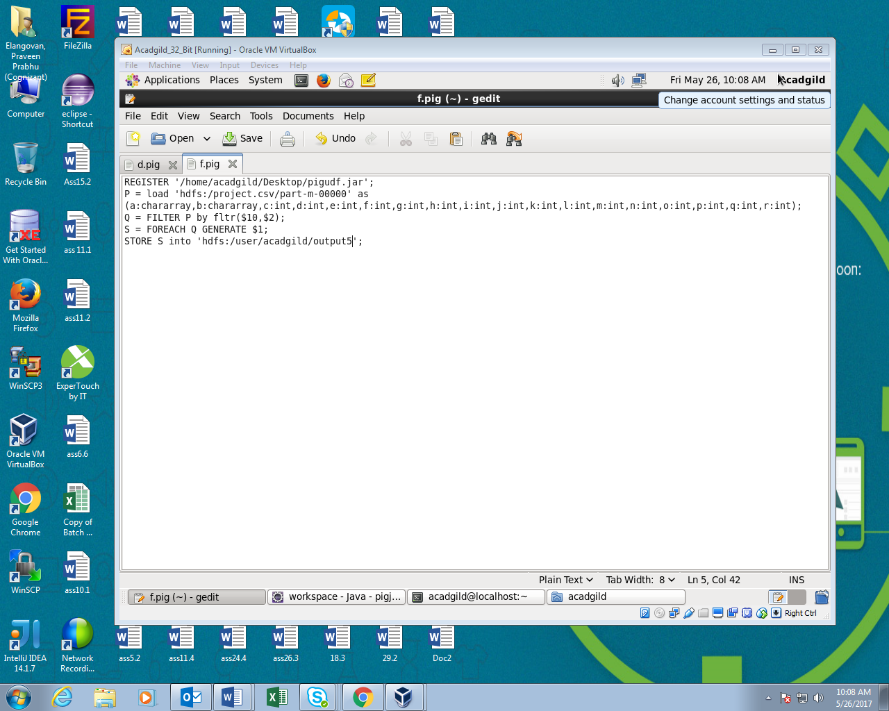

**Step3:Running Pig script**

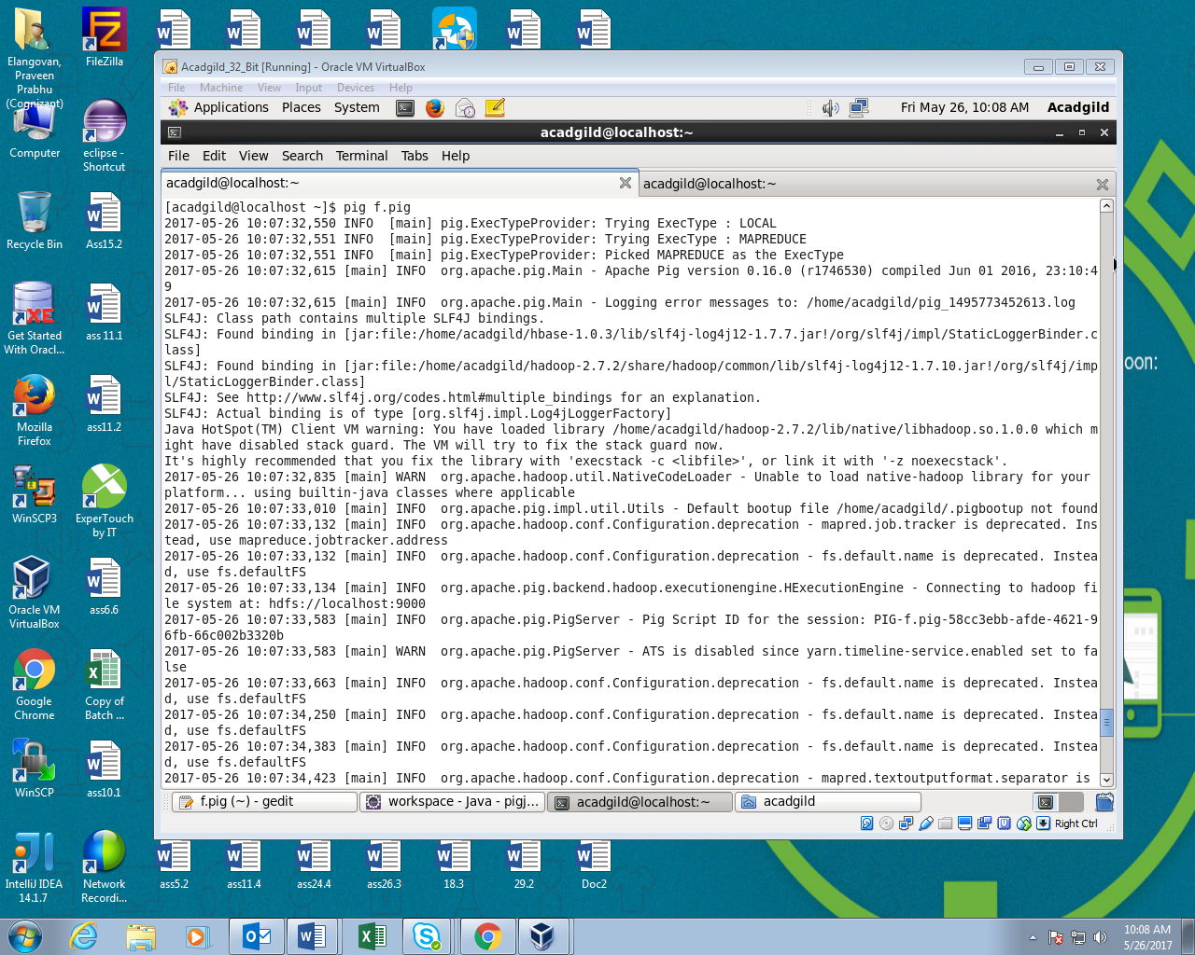

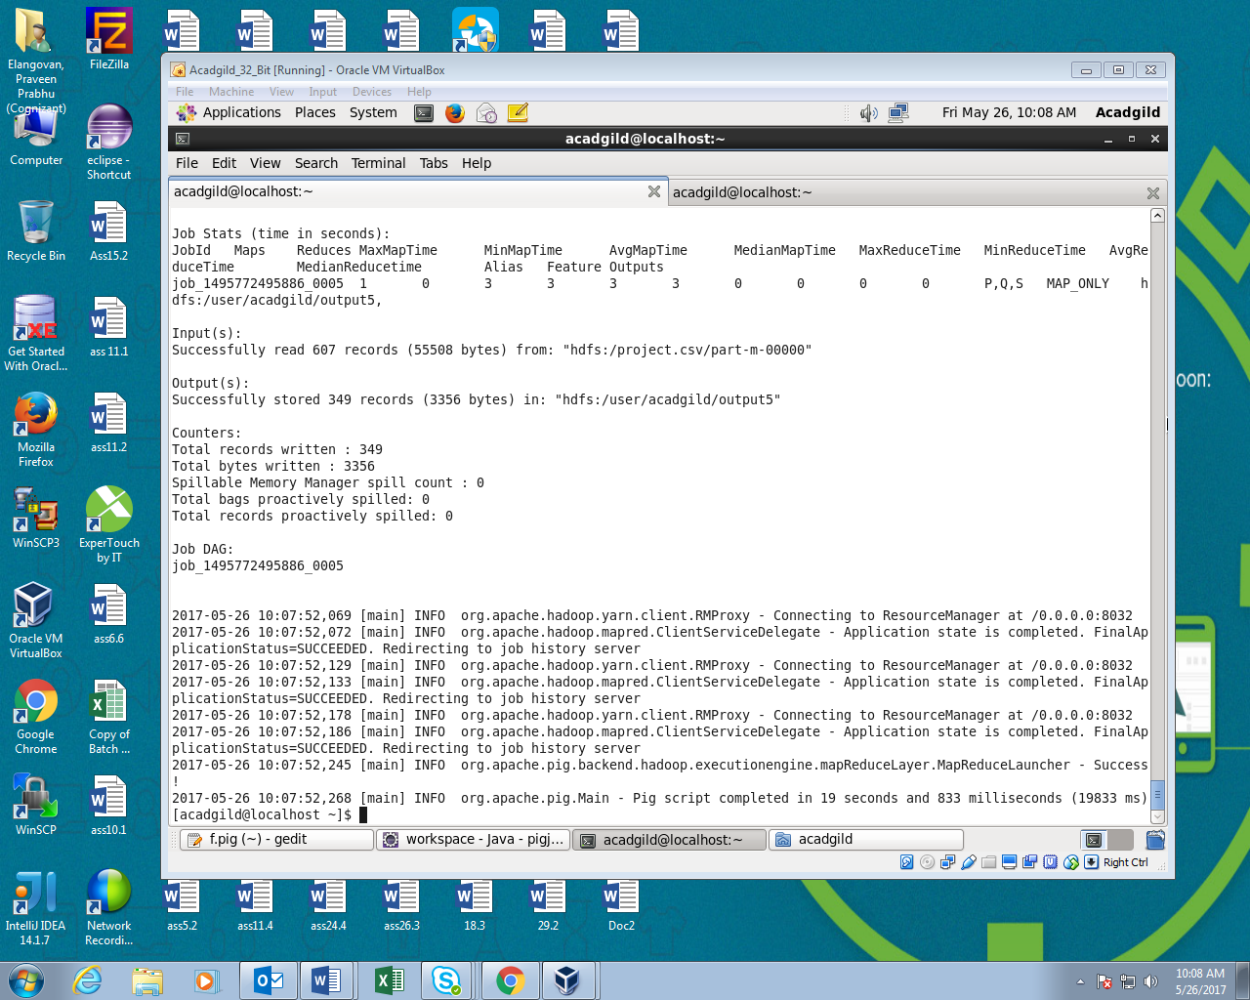

**Step4:Reading filtered data using cat command**

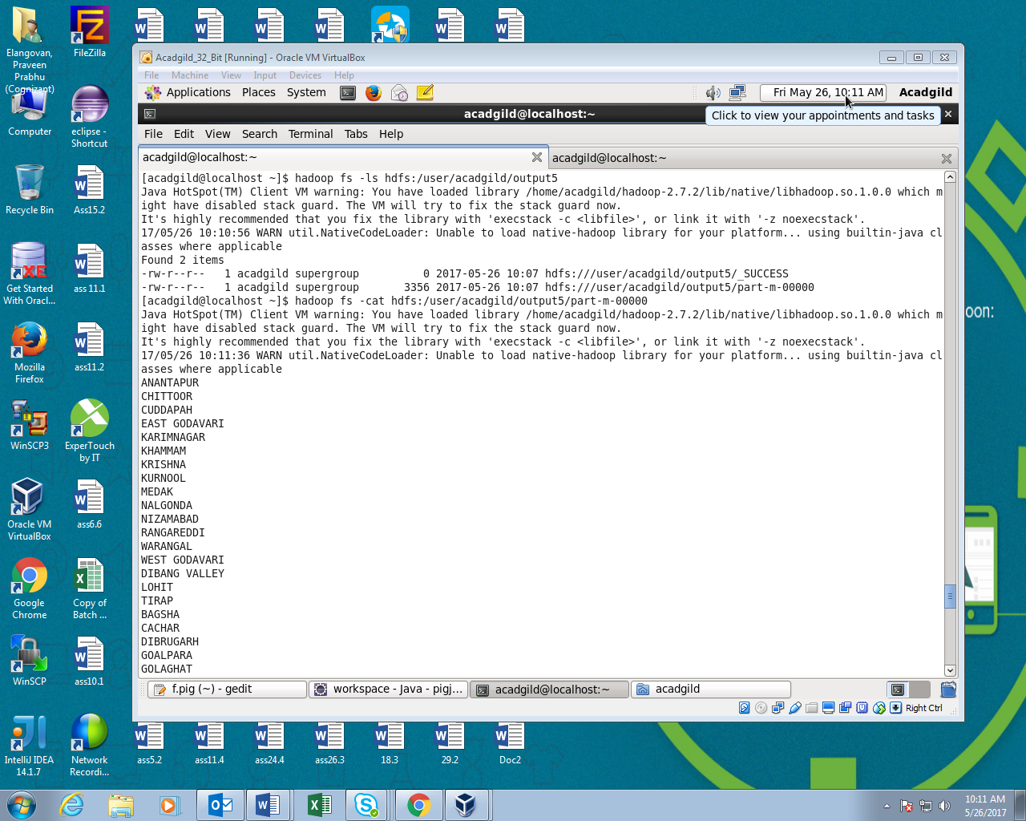

**Step5:Creating table in sql to store the data from pig using sqoop**

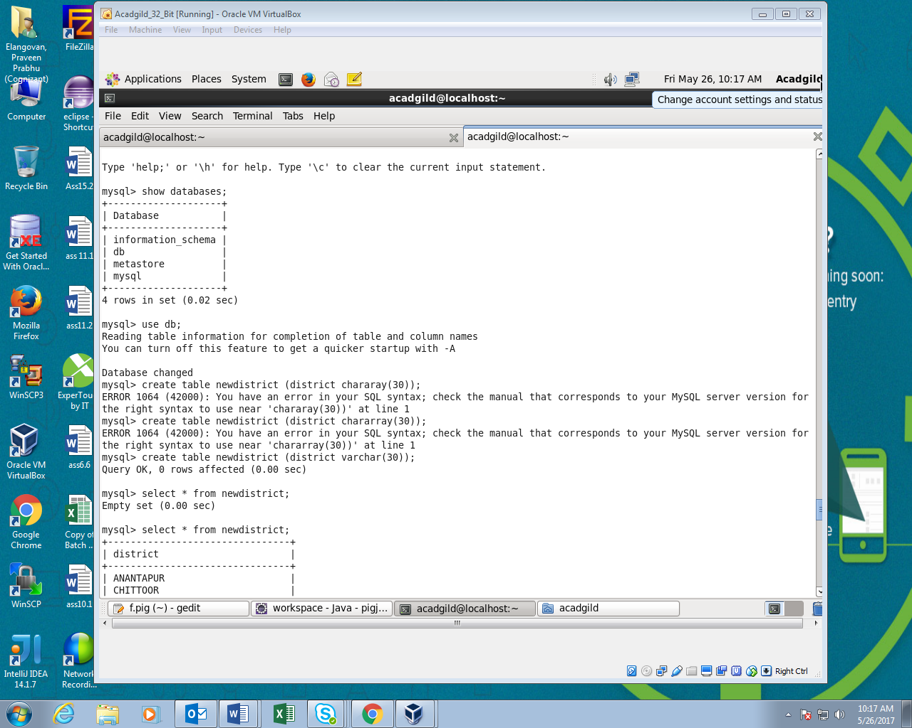

**Step6:Using sqoop I’ve copied the data fro the pig to mysql table**

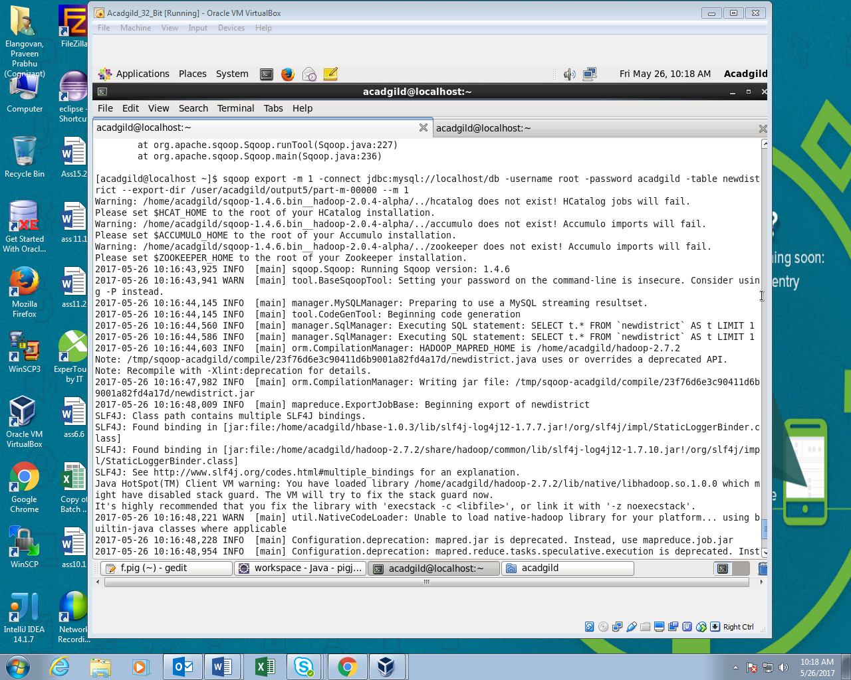

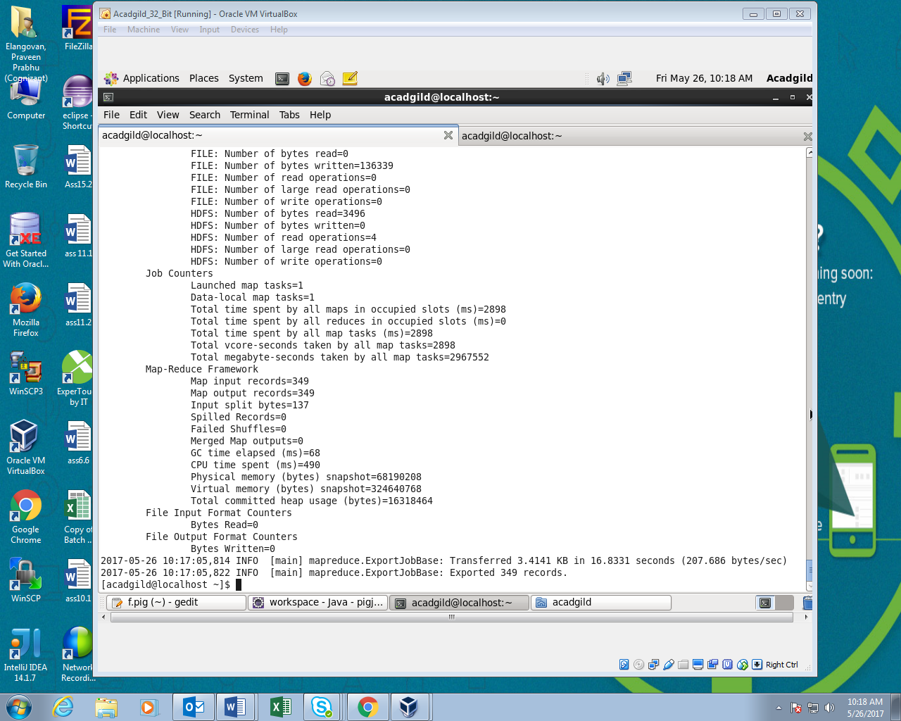

**Step7:Output**

